湖口斷層之長期滑移速率與再現週期

由新竹縣湖口海岸5口鑽井岩心以及定年資料分析，湖口斷層下盤（鳳岡丘陵北側）的紅土礫石層（中壢層）在湖口1號與5號井與鳳岡丘陵頂部紅土礫石層（店子湖層）約有110公尺的高差。但目前尚無法了解湖口1號與5號井中厚約40公尺的紅土礫石層是屬於中壢層或店子湖層；若屬於店子湖層，則湖口斷層兩側的店子湖層則有110公尺的高差。(圖1)

斷層上盤湖口2號至4號井估算的垂直變動大約在1mm/yr至-1mm/yr之間。此外，斷層下盤的湖口1號與5號井因沒有確切的年代資料，而無法估算變動速率。但是，在距離湖口斷層10至20公里的桃園縣新屋以北至桃園縣大園的海岸出露有全新世的藻礁（7600-3800 yr BP），以此估算垂直變動速率，也大致介於1mm/yr至-1mm/yr之間。

本研究參考的震測剖面資料引用自石瑞銓等（2009），湖口背斜構造特性也是受到湖口斷層的彎曲造成的褶皺，屬於斷層轉折褶皺。從地表地質資料結合中油震測剖面，認為湖口背斜應從鳳岡丘陵地區繼續朝西南延伸至頭前溪沖積平原，乃至海域，背斜軸部大致位在頭前溪北岸。由本計畫進行海岸平原的鑽井研究，表示在湖口斷層近斷層上盤區域也似乎呈現微抬升現象（~0.1 mm/yr），但是在頭前溪河口附近（南寮國小井）則呈現較大抬升速率為1.7±0.8 mm/yr，此區域正位於湖口背斜軸部附近。(圖2)

The Long Term Slip Rate and Recurrence Interval of the Hukou Fault

Analyzed from the 5 boreholes on the Hukou coast in Hsinchu County, the lateritic terrace deposits on the Hukou Fault footwall has a 110 m elevation difference against the lateritic conglomerate deposits of Hukou borehole 1, 5 and the top of the Fengling Hills. However, it is still undetermined whether the 40 m lateritic conglomerate of the borehole belongs to the Chungli Formation or the Dianzihu Formation. If it belongs to the Dianzihu Formation, then the elevation difference on the both sides of the fault would be 110 m.
The vertical deformation rate of the Hukou borehole 2 and 4 (on the hanging wall) is estimated to be between 1mm/yr to -1mm/yr. There are no specific dating data on the Hukou borehole 1 and 5, which is on the footwall of the fault, so the deformation rate cannot be calculated. However, from north of Hsinwu in Taoyuan County to the coast in Dayuan, which is 10-20 km away from the Hukou Fault, has an Holocene algal reef outcrop (7600-3800 yr BP). If the vertical deformation rate is thus calculated, then it would still be between 1mm/yr to -1mm/yr.
Based on the seismic reflection profile referred from Ruei Chyuan Shih et al. (2009), the Hukou anticline is a fault-bend fold structure resulted from the curve of the Hukou Fault. The surface geological data and the seismic reflection profile from CPC Corporation, Taiwan shows that the Hukou anticline possibly runs from the Fenggang Hills southwestwards to the Touchien River alluvial plain then into the ocean. The anticline axis is mostly located on the northern coast of the Touchien River. This study conducted on the coastal plain shows that the hanging wall near the Hukou Fault is slightly uplifted (~0.1 mm/yr) But near the Touchien River outfall (Nanliao Elementary School borehole) the uplift rate is higher, 1.7±0.8 mm/yr. This area happens to be near the Hukou anticline axis.
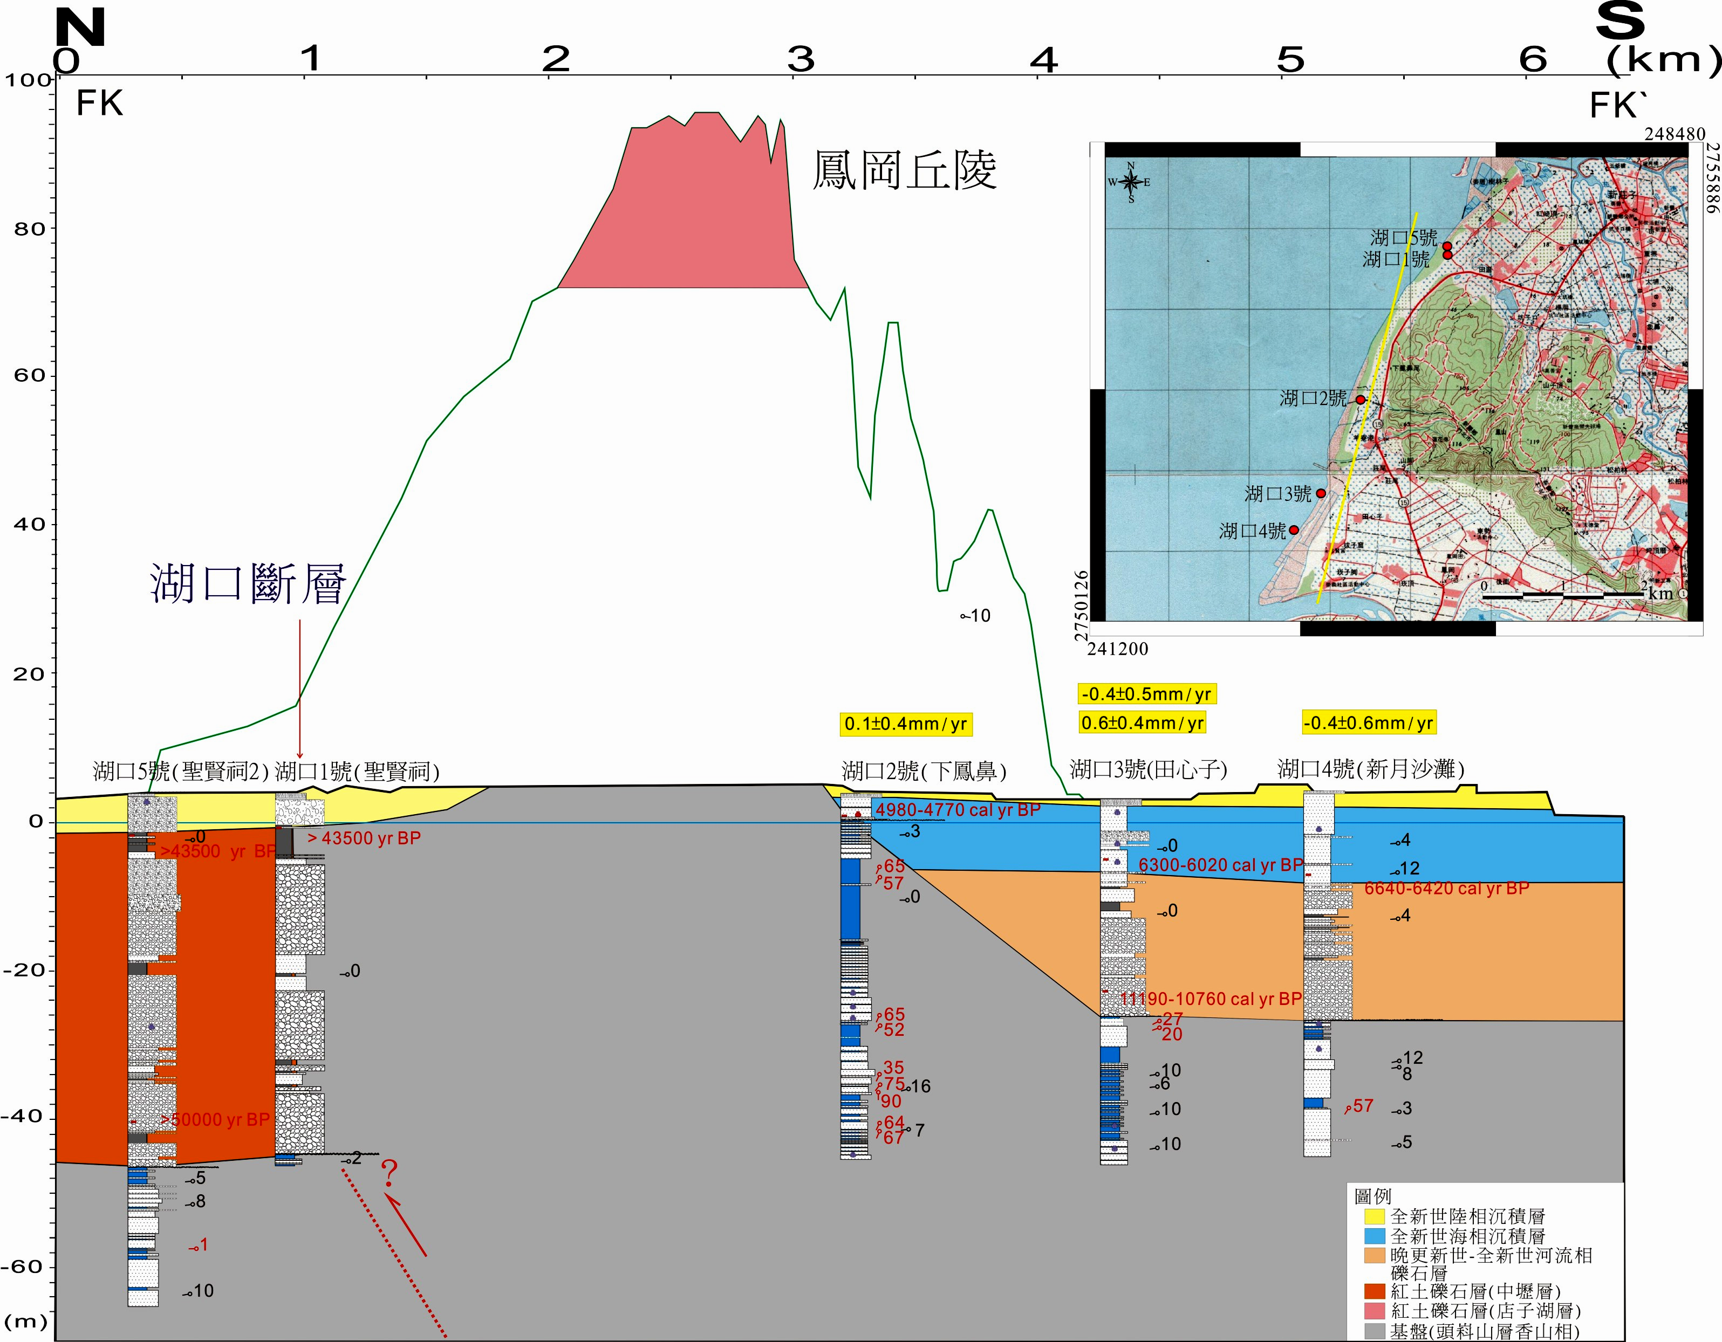
圖1 湖口斷層鑽井岩芯對比，高度與長度比率為1:30。
Contrary to the core of the Hukou Fault borehole, the height to length ratio is 1:30.

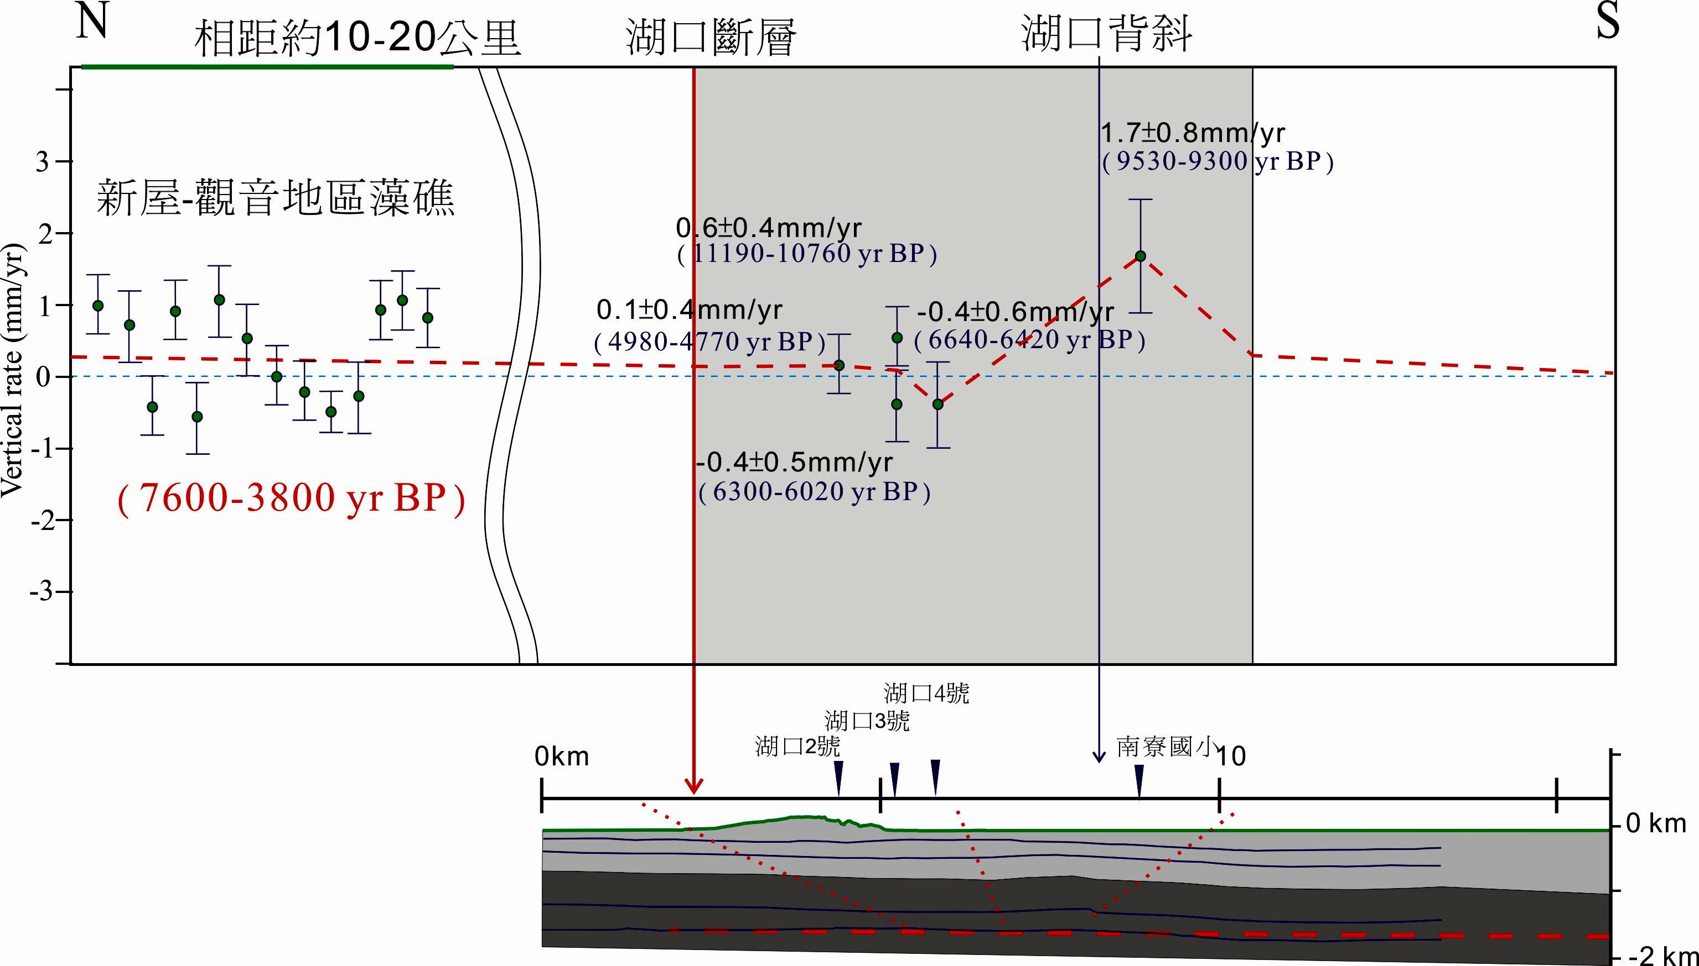圖2 湖口斷層與湖口背斜構造剖面，與長期垂直變動速率。
The profile of the Hukou anticline structure and the long term vertical deformation rate of the Hukou Fault.

